**CTS DIGITAL NURTURE - 4.0 JAVA FSE**

**WEEK 7 -** **React**

**11.ReactJS-HOL**

* **Implement Event handling concept in React applications**
* **Use this keyword**
* **Use synthetic event**

**PROGRAM:**

**App.js**

import React, { useState } from 'react';

import CurrencyConvertor from './CurrencyConvertor';

function App() {

  const [count, setCount] = useState(5);

  const increment = () => {

    setCount(count + 1);

    sayHello();

  };

  const decrement = () => {

    setCount(count - 1);

  };

  const sayHello = () => {

    alert("Hello! Member1");

  };

  const sayWelcome = (message) => {

    alert(message);

  };

  const handleClick = () => {

    alert("I was clicked");

  };

  return (

    <div>

      <p>{count}</p>

      <button onClick={increment}>Increment</button>

      <br/><br/>

      <button onClick={decrement}>Decrement</button>

      <br /><br />

      <button onClick={() => sayWelcome("welcome")}>Say welcome</button>

      <br /><br />

      <button onClick={handleClick}>Click on me</button>

      <br /><br />

      <CurrencyConvertor />

    </div>

  );

}

export default App;

**CurrencyConvertor.js**

import React, { useState } from 'react';

function CurrencyConvertor() {

  const [amount, setAmount] = useState('');

  const [currency, setCurrency] = useState('');

  const handleSubmit = (e) => {

    e.preventDefault();

    const converted = (parseFloat(amount) * 0.011).toFixed(2); // Sample: 1 INR = 0.011 Euro

    alert(`€${converted}`);

  };

  return (

    <div>

      <h2 style={{ color: 'green' }}>Currency Convertor!!!</h2>

      <form onSubmit={handleSubmit}>

        <label>Amount: </label>

        <input type="text" value={amount} onChange={(e) => setAmount(e.target.value)} /><br /><br />

        <label>Currency: </label>

        <textarea value={currency} onChange={(e) => setCurrency(e.target.value)} /><br /><br />

        <button type="submit">Submit</button>

      </form>

    </div>

  );

}

export default CurrencyConvertor;

**OUTPUT:**

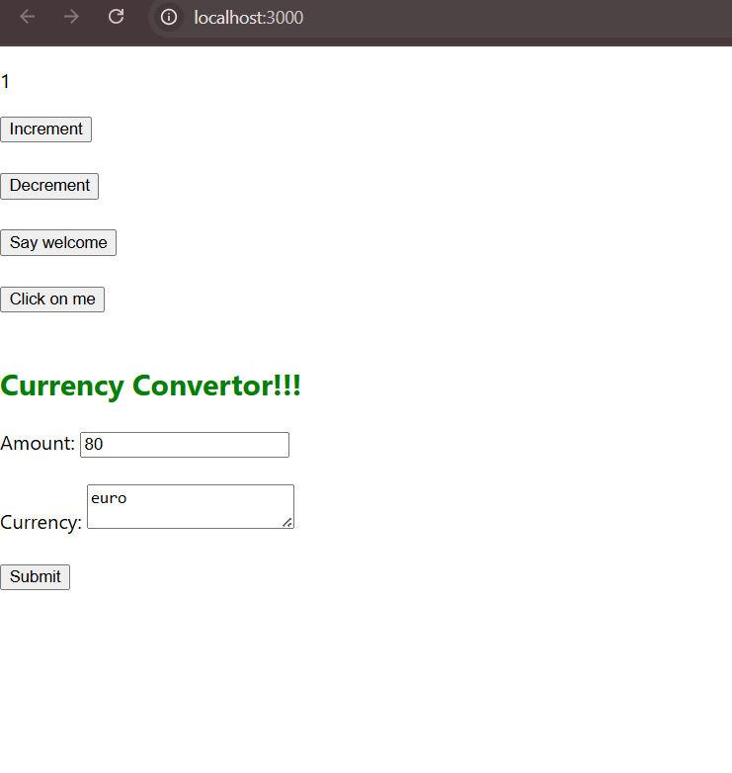

**On clicking increment,**

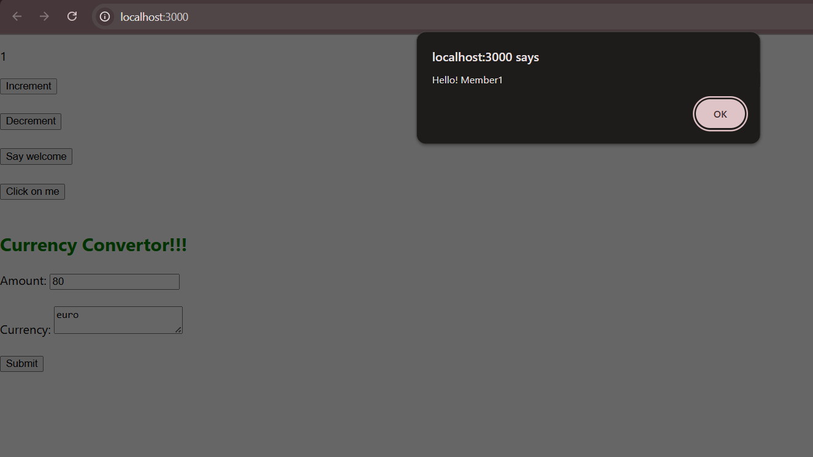

**On clicking welcome,**

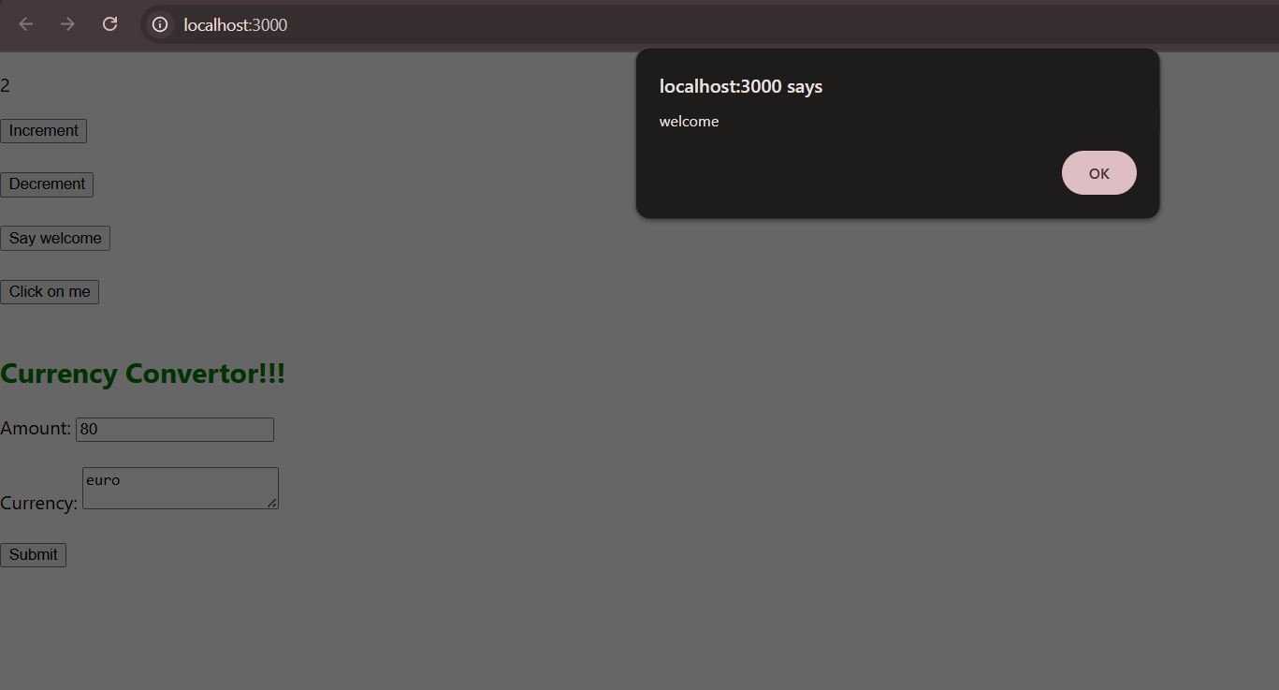

**On clicking click on me,**

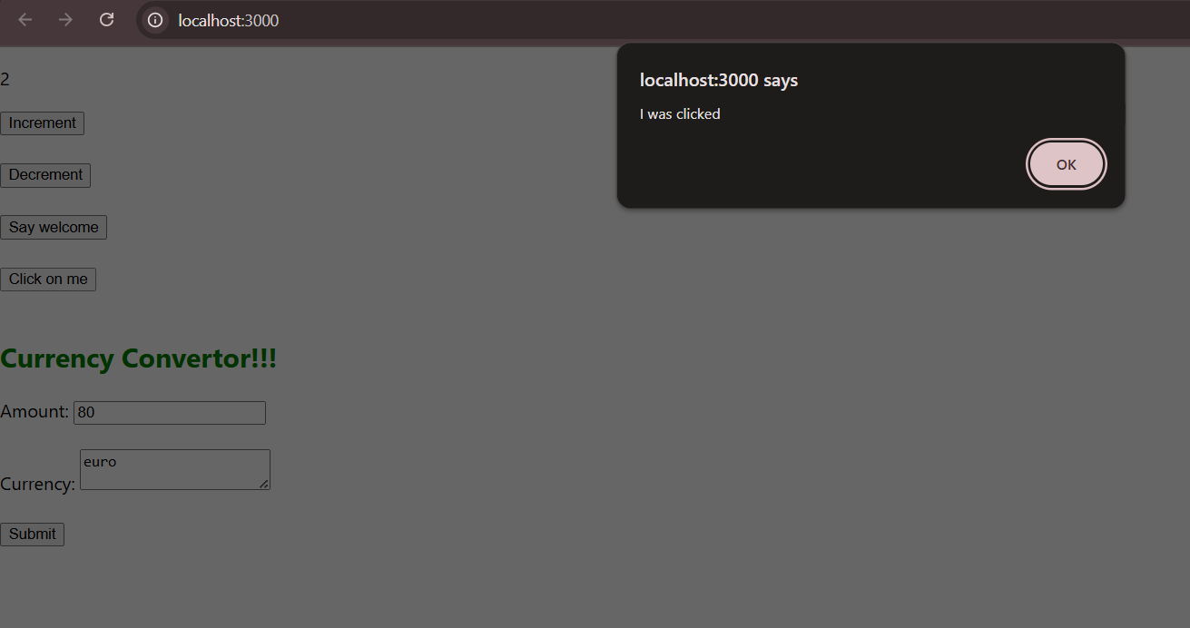

**Converting to euro,**

